﻿ Copyright Transfer Agreement Form
COPYRIGHT TRANSFER AGREEMENT
The Indian Journal of Medical Research(IJMR) is published monthly by the Indian Council of Medical Research, V. Ramalingaswami Bhawan, Ansari Nagar, New Delhi-110029 (India).
The IJMR and Authors hereby agree as follows: In consideration of IJMR reviewing and editing the following described work for first publication on an exclusive basis:
Title of manuscript: Development and ecological validation of a digital exposome ageing index for healthy ageing surveillance in India using LASI Wave 1
The undersigned author(s) hereby assigns, conveys, and otherwise transfers all rights, title, interest, and copyright ownership of said work for publication. Work includes the material submitted for publication and any other related material submitted to IJMR. In the event that IJMR does not publish said work, the author(s) will be so notified and all rights assigned hereunder will revert to the author(s).
The assignment of rights to IJMR includes but is not expressly limited to rights to edit, publish, reproduce, distribute copies, include in indexes or search databases in print, electronic, or other media, whether or not in use at the time of execution of this agreement, and claim copyright in said work throughout the world for the full duration of the copyright and any renewals or extensions thereof.
All accepted works become the property of IJMR and may not be published elsewhere without prior written permission from IJMR. The author(s) hereby represents and warrants that they are sole author(s) of the work, that all authors have participated in and agree with the content and conclusions of the work, that the work is original, and does not i-nfringe upon any copyright, propriety, or personal right of any third party, and that no part of it nor any work based on substantially similar data has been submitted to another publication.

Authors’ Names (in sequence) Signature of Authors
- Dr Siddalingaiah H S 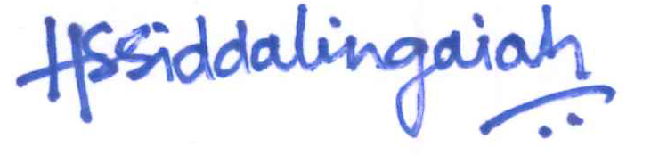

Date: 24/04/2026

